I’ve Got This, WITH JESUS
Join us for our 2022 Vacation Bible School Program
Classes for Children & Adults
Date: July 18th - July 22nd
Time: 6:30 - 8:00 p.m. Nightly
Where: Welcome M.B. Church

Theme Scripture: “For I can do everything through Christ, who gives me strength” (Philippians 4:13, NLT).
Students will explore how faith in God provides opportunities to discover how they can become the best of who they are in Jesus.

Students needing transportation must telephone the
Church Office each day by 12:00 p.m. to request the service.

Please Volunteer: Contact Steve Drake (sdrake303@comcast.net) or sign-up in the Church Lobby on Sunday’s following the 8:30AM worship service, or call the Church Office to Volunteer.

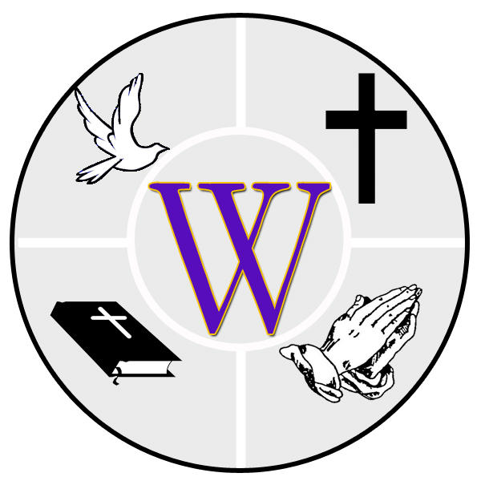
Welcome Missionary Baptist Church
Reverend Douglas P. Jones, Senior Pastor
143 Oneida Road ~ Pontiac MI 48341 ~ 248-335-8740

